**BIONIC ARM**(using Gloves)

**DEFINITION**  
Bionic Arm means an artificial arm. This project is a very minute/minor replication of the human arm’s capability. We were able to successfully implement fingers movement.

This process was achieved using *3D printed arm (material used, Polylactic acid (PLA)*, *micro controller (Arduino Nano)*, *flex/bend sensors* (as the input component) and *servo motors/actuators* (as the output component).

3D-Printed Arm: The arm was printed from the 3D models. Then coupled together. Find the 3D models [here](https://github.com/developersunesis/bionic-arm).

Arduino Nano: is a Nano module of Arduino (micro controller). This serves as the processing centre of the I/O components.

Flex/Bend sensor: is an analog component, we can obtain degrees of bend from this component up to 180 degrees.

Actuators/Servo motors: this an output component, it reads values in degrees and rotates by the speculated degree.

**HOW IT WORKS**

The bend degree of the glove fingers (from the flex sensors which are attached on the gloves) are sent to the micro controller, (the reading ranges from analog components which includes *flex sensor* is 0 - 1024).

The values from each sensor (which is a number from 0- 1024) is mapped to degrees between and including 0 – 180. Then, the mapped value is written to the specified servo motor which then moves the finger its attached to.

This process is repeated continuously.

Analog value read from sensor

Digital value / mapped value is then sent to the servo motor

Analog value is converted to digital value and mapped to 0 – 180 degree

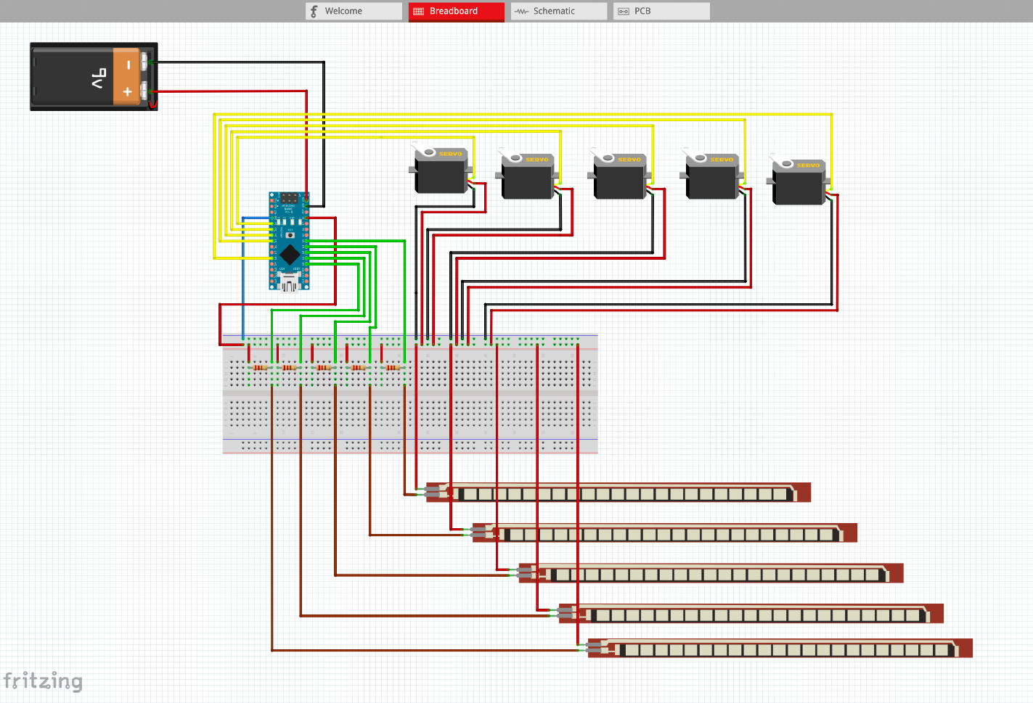**CIRCUIT SIMULATION** (from [fritzing.org](https://fritzing.org))

**Tools/Materials used**

1. Arduino IDE
2. Micro controller (Arduino Nano)
3. 3D printed arm
4. 5 servo motors/actuators
5. 5 bend/flex sensors
6. 5 resistors
7. Double-Faced Circuit board
8. Six 6-Watt batteries
9. Heavy-duty glove
10. Fishing line

Others

1. Jumper wires
2. Soldering Iron and solder
3. Glue gun
4. Probably scissors, pliers, screwdrivers and blade

**Attached in the root folder of this document are:**

*bionic_arm*

This directory contains the main code that controls the micro controller. And it’s the program currently been run on the micro controller.

*test_case*

This directory contains the test code used to obtain the values of the flex sensor.

**ISSUES AND OBSERVATIONS**

1. Fingers not closing completely.

**Solution**: (I made flaw to have permanently glued the moveable joints/parts of the palm). Also, the rotation of the finger is affected by the space between the glove when your fingers are closed or open. Reprinting might be the only solution for my case. So please take caution while coupling your 3D printed components together.

1. The middle finger isn’t responding appropriately.

**Solution**: Get a new flex/bend sensor (for my case).

1. The fingers needs assistance/support to completely rise straight.

**Solution**: (not ideal) But the only solution to this I think is to replace the fishing line in that finger or reprint the finger and add fishing line appropriately

1. A finger is slowly responding to glove movement

**Solution**: Replace the finger’s battery (power source)

1. Fingers are all moving improperly/too sharp

**Solution**: Unplug the charger of the PC (ensure no external power source is connected to PC that powers the micro controller) or use battery for micro controller.

1. Finally, overtime I found out that this is only an issue I couldn’t totally eradicate.

**Solution:** (Unsolved)

**CREDITS**  
***Inspired by*** Professor Christiana P. A.  
(*Prosthetics and Orthotics, Federal University of Technology Owerri – FUTO*)   
  
InMoov   
(Right Arm *3D models –* [*https://inmoov.fr/inmoov-stl-parts-viewer/?bodyparts=Right-Hand*](https://inmoov.fr/inmoov-stl-parts-viewer/?bodyparts=Right-Hand))

Stampar Prints

(*3D printing –* [*info@stampar3d.com*](mailto:info@stampar3d.com)*)*

Mr. Ibrahim   
(*Inspired Circuit Design*)